FINAL PUBLIC NOTICE
The City of Gulfport has applied for Federal Emergency Management Agency (FEMA) funding through the Mississippi Emergency Management Agency (MEMA), as an Applicant.
Under the National Environmental Policy Act (NEPA), federal actions must be reviewed and evaluated for feasible alternatives and for social, economic, historic, environmental, legal, and safety considerations. Under Executive Order (EO) 11988 and EO 11990, FEMA is required to consider alternatives to and to provide a public notice of any proposed actions in or affecting floodplains or wetlands. EO 12898 also requires FEMA to provide the opportunity for public participation in the planning process and to consider potential impacts to minority and low-income populations. This notice may also fulfill requirements under Section 106 of the National Historic Preservation Act (NHPA).
Funding for the proposed project will be conditional upon compliance with all applicable federal, tribal, state, and local laws, regulations, floodplain standards, permit requirements and conditions.
Applicant: City of Gulfport
Project Title: Ken Combs Pier
Location of Proposed Work: Harrison County, City of Gulfport
Name of Structure: Ken Combs (Fishing Pier)
Address of Structure: 96 Courthouse Rd, Gulfport, MS 39507

Facility | Address | Latitude | Longitude | Date of Construction
Ken Combs Pier | 96 Courthouse Rd, Gulfport, MS 39507 | 30.37678 | -89.04390 | 2008

Special Flood Hazard Area Zone: The site is located in a Coastal High Hazard Area (CHHA) - VE Zone. Confirmation of location in a Special Flood Hazard Area (SFHA) was determined by the Harrison County Flood Insurance Rate Map, Panel Number: 28047C0268G, dated 06/16/2009. The proposed work conforms to all applicable State of Mississippi and local floodplain regulations. During the hurricane event, the Ken Combs Pier was damaged due to storm surge and hurricane winds.
There is a potential for the facility to be impacted by future flooding events due to its location within the VE Zone. The proposed work will take place in wetlands per the United States Fish and Wildlife Service National Wetlands Inventory (E1UBL - Estuarine subtidal unconsolidated bottom).
Proposed Work and Purpose:
The City of Gulfport will utilize contract and/or force account services for the repairs of the Ken Combs Pier to restore this facility back to its pre-disaster design, function, and capacity (in-kind) within the existing footprint.
In addition, to protect against future damages, the applicant has requested 406 mitigation funding to install flow through decking over concrete stringers/pile caps along with stainless steel bolts. This will reduce the uplift water pressure on the entire system.
The purpose of mitigating the Ken Combs Pier is to restore the facility to allow for a continuation of recreational activities.

Project Alternatives:

Alternative #1 (no action alternative): If no action is not taken to restore the damage to the Ken Combs Pier, it will impact the overall well-being of the community.

Alternative #2: Relocation of the Ken Combs Pier is not practical nor cost-effective. The Ken Combs Pier is functionally dependent due to its location within the floodplain and serves the purpose of providing open space use for recreational activities.

Comment Period: Comments are solicited from the public, local, state or federal agencies, and other interested parties in order to consider and evaluate the impacts of the proposed project. The comments should be made in writing and addressed to the City of Gulfport. All comments are due within 15 days of this notice. The City of Gulfport will forward comments to applicable regulatory agencies as needed.

Interested persons may submit comments, obtain more detailed information about the proposed action, or request a copy of the findings by contacting: U.S. Department of Homeland Security, Federal Emergency Management Agency – Region IV - EHP, 3005 Chamblee Tucker Rd – Office #255, Atlanta, GA 30341-4112 or by email at FEMA-R4EHP@fema.dhs.gov. Please include in the subject line of the email “DR-4576-MS EHP FIT.” Comments should be sent in writing at the above address within 15 days of the date of this notice.
POSTED ON: (___________________)

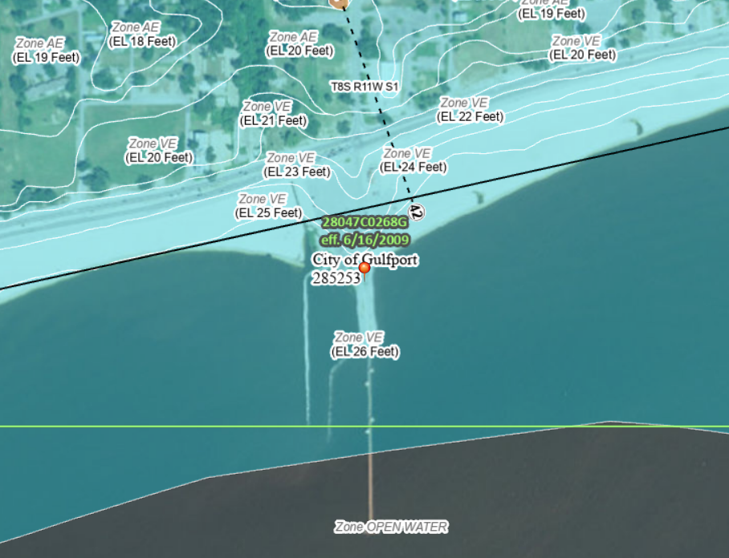
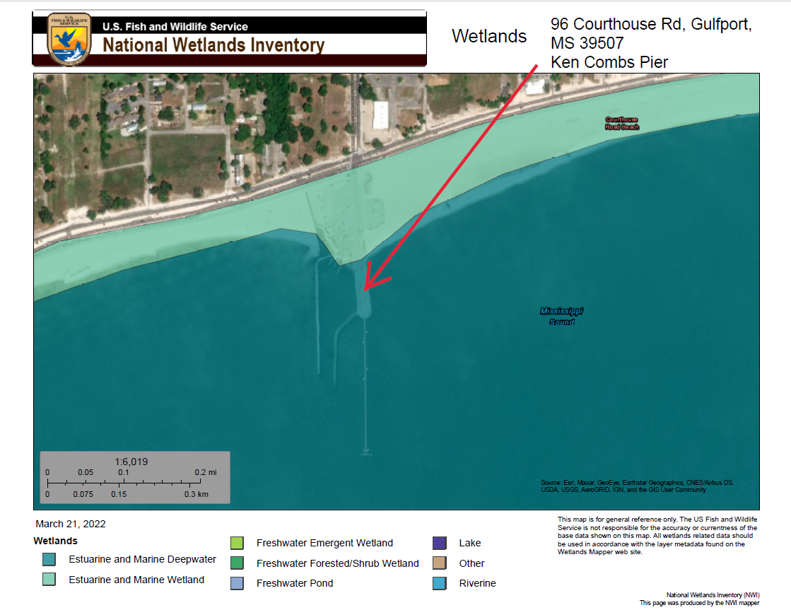

End of Notice

